**ITEC 50 – WEB SYSTEM AND TECHNOLOGIES**

**FINAL PROJECT DOCUMENTATION**

**Content**

1. Title Page
2. Table of Contents
3. Company Background
4. Company History (if any)
5. Company Location (Google map)
6. Organizational Chart
7. Gallery (Business Establishment)
8. Web Content (what are the pages of the websites)
9. Sitemap
10. Screenshot (User Interface with description)
11. Source code
12. About the Developers
13. Evaluation Result

**Grading Percentage**

Documentation - 30%

Client Evaluation - 30%

Customer Evaluation - 20%

Instructor Evaluation - 20%

100%

**Sample Sitemap**

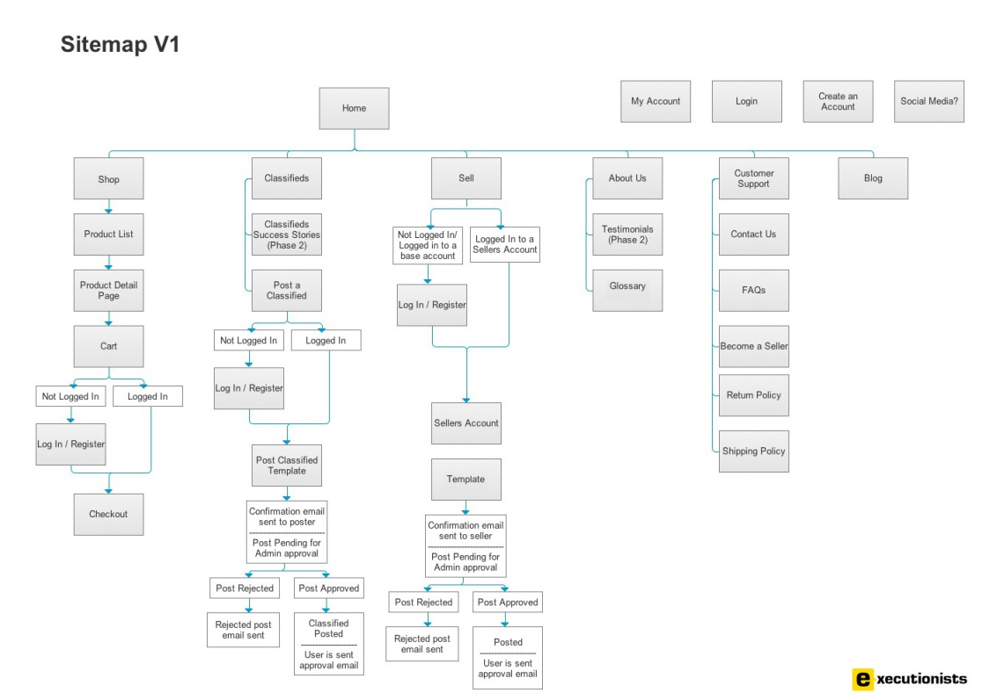

NAME OF THE COMPANY WEBSITE

**FINAL PROJECT**

**ITEC 50 – Web System and Technologies**

Submitted to

**PROF. JEFFREY F. PAPA**

Instructor III  
Information Technology Department  
Cavite State University Naic  
Bucana, Naic, Cavite

FIRSTNAME M.I. LASTNAMEFIRSTNAME M.I. LASTNAMEFIRSTNAME M.I. LASTNAMEMay 2019